SUBMISSION COMMENTS ON OMV’S MAARI FIELD OIL DEVELOPMENT
Legislative Background
Section 59(2)(d) and (e) of the EEZ Act requires EPA to consider “the importance of protecting the biological diversity and integrity of marine species, ecosystems, and processes” and (e) “ the importance of protecting rare and vulnerable ecosystems and the habitats of threatened species.”
Section 11 (b) of the EEZ Act refers to the importance of NZ’s international obligations, including those under the CBD.
Section of the EEZ Act section 39(1)(c) requires an IA to “identify the effects of the activity on the environment and existing interests (including cumulative effects and effects that may occur in New Zealand or in the sea above or beyond the continental shelf beyond the outer limits of the exclusive economic zone)” while section 59(2)(a)(i) states that “EPA must take into account any effects on the environment or existing interests of allowing the activity, including cumulative effects…”
Effects on Threatened Marine Mammals and the Marine Environment
Lack of Population Surveys
There are no systematic marine mammal population surveys to robustly assess the direct, indirect and cumulative impacts of the programme on potentially affected species.

Blue Whales
The programme directly and indirectly threatens recently discovered foraging grounds of Endangered Blue whales through increased noise, pollution, ship strikes, as well as through loss and degradation of habitat and food supplies.

Maui’s Dolphins
Maui’s dolphins are the world’s smallest and rarest marine dolphin and New Zealand’s only endemic cetacean. Populations have progressively declined from an estimated 1.800 in the 1970 to less than 50 individuals today. The programme directly and indirectly threatens the survival of this critically endangered and declining remnant population through increased noise, chemical and other forms of pollution, ship strikes, as well as through loss and degradation of habitat and food supplies, stress and displacement. The extreme scarcity and downward trend of Maui’s dolphins mean that this subspecies is supremely vulnerable to any form of anthropogenic disturbance and can only sustain a single human induced mortality every 10-23 years.

The IA makes erroneous assumptions about the distribution of Maui’s dolphins and thus underestimates and misrepresents the risk of its activities on this Criticall Endangered subspecies.
Synergistic and Cumulative Effects
Synergistic and cumulative effects on the endangered marine and the marine biodiversity (e.g., seismic blasts, marine mining, vessel traffic, fishing, etc.) are not taken into account. These include those of other OMV fossil fuel exploration and drilling activities south and north of the Maari development programme under consideration.

Oil Spills and Accidental Discharge
The risks to marine and coastal biodiversity and ecosystems, and more specifically habitats of threatened species are too great if a major oil spill occurs, as are the impacts on fisheries, local livelihoods, economy and human health. OMV’s impact assessment (IA) does not provide adequate information and analysis on these risks and potential effects (e.g., http://www.epa.govt.nz/eez/EEZ000007/EEZ000007_ERM_Completeness_Evaluation.pdf).

Oil spills have the capacity to cause or contribute to the extinction of Maui’s dolphins and the extirpation of Blue whales in New Zealand.

The projected oil spills trajectories presented on behalf of OMV are limited and most likely inaccurately reflect of the full extent and spread of a potential oil spill. Despite their limitations OMV’s oil spills trajectories demonstrate a significant aerial overlap with the habitat of Blue whales and Maui’s dolphins (see sample Figure below)

. 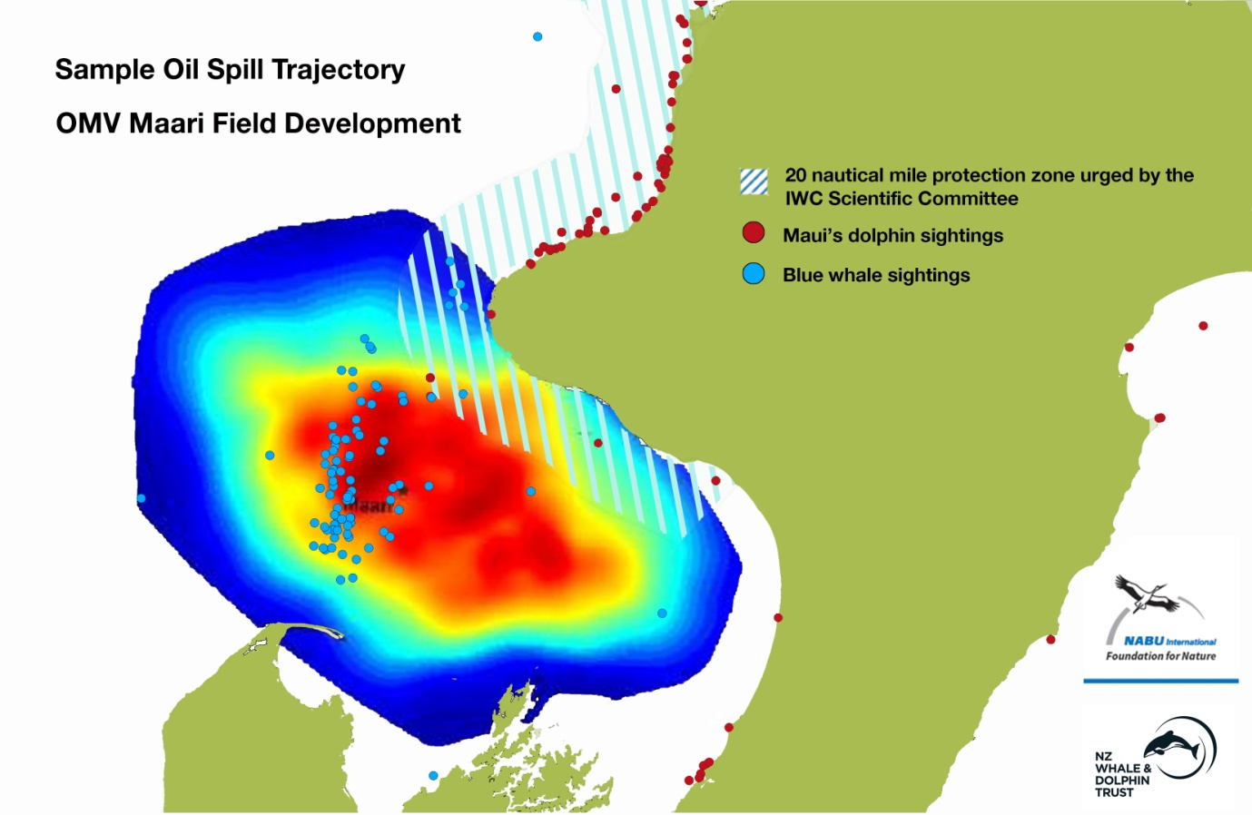

New Zealand has already experienced two significant oil spills associated with offshore oil and gas production in 2007 and 2010. Both were associated with floating production, storage and offload (FPSO) facilities. An increased number of wells, together with increased levels of offshore storage and offloading of oil to shuttle tankers will intensify these risks. The grounding of the MV Rena off Tauranga in 2011 further highlights the potential harmful impact of oil spills on New Zealand’s fauna.
Moreover, Currey (2012) explains that is not only the “oil itself that may impact on the dolphins, but many aspects of an oil spill response will have direct or indirect effects on the population, eg, the use of dispersants to clean up the oil, increased vessel activity in the area, the use of sonar for tracking lost cargo etc.”
These circumstances are further exacerbated by the fact that New Zealand’s ability to deal with an offshore oil spill is poor due to a lack of specialist response equipment and resources.
Discharge of harmful substances and contaminants
Effects on marine ecosystems and human health cannot be fully assessed without full disclosure of the substances involved; e.g. SBMs and “completion fluids”, the latter are known to contain hazardous and toxic additives.

Economic Implications
OMV’s economic benefit analysis is incomplete and misleading. The IA provides little quantitative information specific to OMV’s Maari Field Development programme. Instead, it offers mostly information on jobs and incomes (royalties and taxes) related to the oil and gas industry nationwide.

Furthermore, OMV’s analysis fails to take account of potential economic losses caused by a major oil spill, such as cleanup cost and losses to the fisheries and tourism sectors. While the relatively small Rena disaster cost Maritime New Zealand $36.8 million, BP paid US$43 billion towards the cleanup of the Gulf of Mexico deep water horizon disaster by October 2013.

